**GANPAT UNIVERSITY**

**U.V.PATEL COLLEGE OF ENGINEERING & TECHNOLOGY**

**Department of Computer Science and Engineering**

**B.Tech 1ST  Semester   Subject – ESFP**

**First Name: Akash Bhardwaj**

**Enrollment Number:T14012101005**

**Stream : CBA**

**Practical – 3                                                                            Date:27/08/14**

Goal

**Practical -3**

**Objectives :**

**1. Write a program to print ASCII values of all backslash characters and white space on screen in following format :**

**The ASCII value of ‘\t’ is : 9**

**(Hint : you can verify your ASCII values with the help of a table for ASCII values from text book)**

**1.1**

**Code**

#include<stdio.h>

#include<conio.h>

void main()

{

char a,b,c,d,e,f,g,h,i,j,k,l,m;

a='\a';

b='\b';

c='\f';

d='\n';

e='\r';

f='\t';

g='\v';

h='\\';

i='\'';

j='\"';

k='\?';

l='\N';

m='\XN';

clrscr();

printf("\nThe Ascii value of \\a is :%d",a);

printf("\nThe Ascii value of \\b is :%d",b);

printf("\nThe Ascii value of \\f is :%d",c);

printf("\nThe Ascii value of \\n is :%d",d);

printf("\nThe Ascii value of \\r is :%d",e);

printf("\nThe Ascii value of \\t is :%d",f);

printf("\nThe Ascii value of \\v is :%d",g);

printf("\nThe Ascii value of \\\ is :%d",h);

printf("\nThe Ascii value of \\' is :%d",i);

printf("\nThe Ascii value of \\\" is :%d",j);

printf("\nThe Ascii value of \\\? is :%d",k);

printf("\nThe Ascii value of \\N is :%d",l);

printf("\nThe Ascii value of \\XN is :%d",m);

getch();

}

Output:-

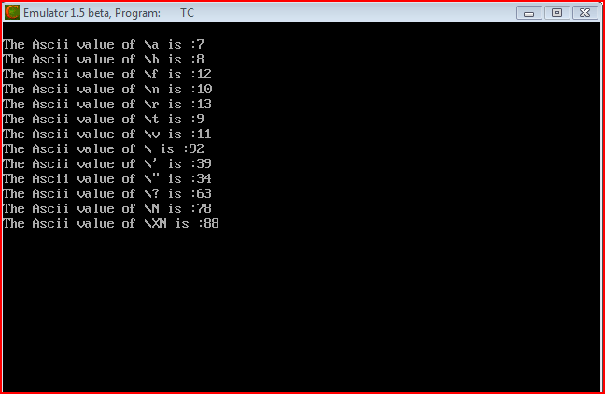



**2. Explain different data types available in C.**

**Ans:-Data types in C language can be classified into the following categories.**

**1. Basic Data type**

**2. User Defined Data type**

**3. Enumerated Data type**

**4. Empty Data set.**

**BASIC DATA TYPE**

**Basic data type includes the Integers, real numbers and Characters or string.**

**There are Key words to define these data types.**

**int is used to declare Integer variables.**

**Eg: int a, b; // here the variables a and b can hold only the integer value**

**float is used to declare Real numbers or floating point numbers.**

**Eg: float x, y; // Here the variables x and y can hold only the real or floating point numbers.**

**char is used to declare characters or string.**

**Eg:char ch; //Here the variable ch can store a single character.**

**double is used to declare a variable which can hold a large number.**

**Eg:double z;**

**USER DEFINED DATA TYPE**

**User defined data type are those which are derive from the basic data types. Some of the user defined data types areArrays ,Structures ,Unions.**

**Arrays**

**Arrays can be defined as the collection of similar type of data. For example, if you want to store 100 different values, you cannot use 100 variables. Instead you can define it as an array. Each value in the array can be retrieved using the subscript.**

**Eg:**

**int Mark[100]; // here the variable mark is defined as an array and it can hold 100 values of type integer.**

**Structures**

**Structures are nothing but a collection of data items. Unlike in arrays, it can hold set of data items of different data types under a single name. This data type can be created using the keyword “struct”**

**Eg:**

**struct student**

**{**

**int rno;**

**char name[25];**

**float avg;**

**};**

**struct student s1, s2;**

**In the above example, student is an user defined data type. The structure variable s1 consist of 3 values namely rno, name and avg.**

**The values can be accessed as follows**

**s1.rno, s1.name, s1.avg**

**Union**

**Union is same as that of structure, here the main difference is in the allocation of memory. In structure the memory is allocated for each and every members.**

**Eg:**

**union student**

**{**

**int rno;**

**char name[25];**

**float avg;**

**};**

**union student s1, s2;**

**ENUMERATED DATA TYPE**

**Enumerated data types are those in which a variable can contain only some specific set of values. For example if a variable needs to hold only the moths, it can have any one of the values from January to December.**

**Eg:**

**enum months = { “January”, “Feburary”, “March”, “April”, “May”, “June”, “July”, “August”, “September”, “October”, “November”, “December” };**

**months m1, m2;**

**here the variables m1 and m2 are of enumerated data types. It can hold only the values from January to December as declared.**

**EMPTY DATA SET.**

**As the name indicates, it contains nothing or a NULL value. This data type is used to specify return values of function. If there is nothing to return from a function, the return type can be specified as “void”**

**Eg:**

**void main()**

**{**

**-----**

**------**

**}**

**3. Explain about C Tokens in brief.**

**Ans:-In a C source program, the basic element recognized by the compiler is the "token." A token is source-program text that the compiler does not break down into component elements.**

**Syntax**

**token:**

**keyword**

**The keywords, identifiers, constants, string literals, and operators described in this section are examples of tokens. Punctuation characters such as brackets ([ ]), braces ({ }), parentheses ( ( ) ), and commas (,) are also tokens.**

**C token is an individual word present in the c-language. There are 6 types**

**Keywords: keywords are defined by the software with the specified meaning.**

**In c language 32 keywords are there**

**Example: double, int, etc**

**Identifiers:User defined variable names.**

**Constants: The value which is not changed during the execution**

**Strings: Group of caharacters enclosed in " "**

**Operators: The following are the operators available in c**

**1.Arthematic Operators are as follows [+,-,*,/,%]**

**2.Assignment Operators are as follows [=]**

**3.Relational Operators are as follows [<,<=,>,>=,==,!=]**

**4.Logical Operators are as follows [and,or,not]**

**5.increment/decrement Operators are as follows [++,--]**

**6.Bitwise Operators are as follows [&,|,~,^,>>,<<]**

**7.Conditional or terinary Operator:[?:]**

**Special characters are as follows ,(comma) -to seperate 2 variables sizeof Operators -returns the size of the variable**

**4. Explain about backslash characters in C.**

**Ans:-The backslash is a trigger. It says the next character is special. \n is new line, \t is tab, \b is backspace. So logically, the backslash alone can't be used to display a backslash, so you use \\ to display one backslash.**

**Backslash Commands**

**When used in a character or string expression, the backslash character (\) is used to**

**give instructions to cout.   For example, \n has the identical effect of endl.      For example:**

**cout << “This is on one line.” << ‘\n’ << “This is on another line.”;**

**will produce the output**

**This is on one line.**

**This is on another line**

**The only advantage of \n is that it can be included in a string.      For example:**

**cout << “This is on one line.\nThis is on another line.”;**

**will also produce the output**

**This is on one line.**

**This is on another line**